1. Newsroom
Subtitle:
Stay updated with Flo Mobility's latest media coverage, product launches, industry recognition, events, and company milestones.
2. News & Updates
Subtitle:
Explore the latest stories, announcements, media features, product launches, and milestones from Flo Mobility.
3. Milestones & Media
Subtitle:
Discover the defining moments in Flo Mobility's journey through product launches, industry recognition, media features, and key events.
1. Title: YourStory: Flo Mobility Builds Robots That Haul Construction Materials
Description: YourStory featured Flo Mobility's autonomous robotics platform and its mission to transform construction material movement through Physical AI.
July 2026
Button: Read Full Article → Flo Mobility builds robots that haul construction materials. L&T and Godrej use them | YourStory

2. Title: BuiltWorlds Recognizes Flo Mobility Among the 2026 Robotics Top 50
Description: Flo Mobility was recognized by BuiltWorlds as one of the world's leading robotics companies driving innovation in construction and material transport.
July 2026
Button
View Recognition → https://www.linkedin.com/posts/builtworlds_were-excited-to-release-the-2026-robotics-activity-7480728390212218881-PHOc?
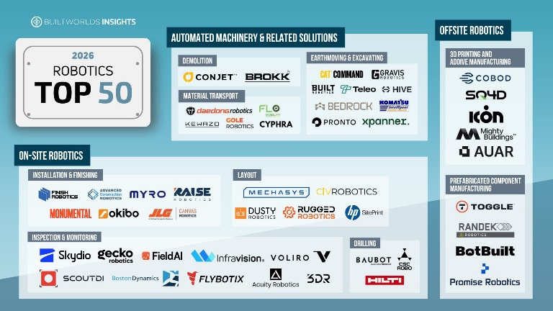

3. Title
The Economic Times: Flo Mobility Featured Among India's Construction AI Innovators
Description
The Economic Times highlighted Flo Mobility's role in advancing AI-powered robotics to address labour shortages and improve construction productivity.
Date
May 2026
Button
Read Full Article → Startups lead AI push into construction amid labour shortages - The Economic Times
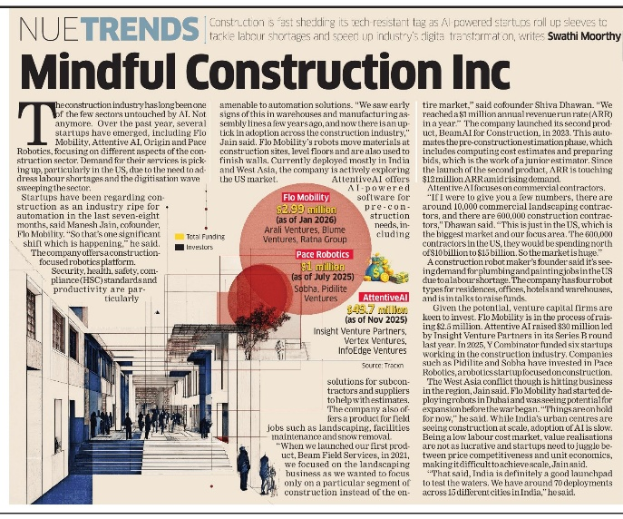

4. Title
Flo Mobility Showcases Its Vision at ELEVATE X – Startup Leadership Think Turf
Description
Flo Mobility joined leading founders, investors, and industry experts to discuss the future of Physical AI and robotics.
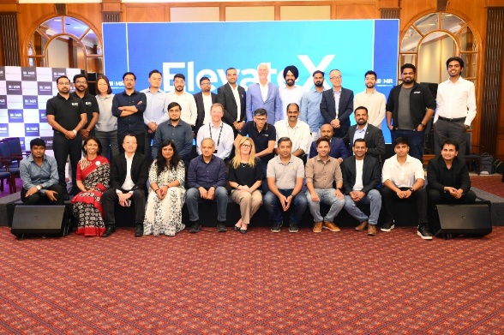
Date
February 2026

5. Title
SRX Podcast: Flo Mobility Founder Manesh Jain on Building Robotics for Construction
Description
Founder & CEO Manesh Jain shares Flo Mobility's journey, from early product development to real-world deployments, fundraising, and the future of construction robotics.
Date
February 2026

Button
Watch Podcast → https://lnkd.in/duceA_5T

6. Title
Flo Mobility Participates in NICMAR AGNI IGNITE – North Conclave 2026
Description
Founder & CEO Manesh Jain joined industry leaders and innovators to discuss the future of construction, technology, and infrastructure.
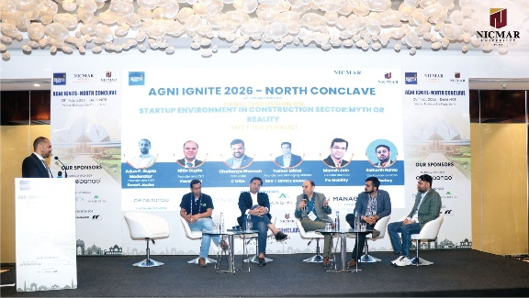
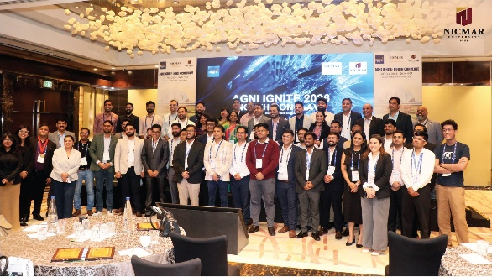
Date
March 2026

7. Title
ETV Bharat Features Flo Mobility's Autonomous Wheelbarrow for Construction
Description
ETV Bharat highlighted Flo Mobility's Made-in-India autonomous wheelbarrow designed to improve construction productivity and safety.
Date
November 2025
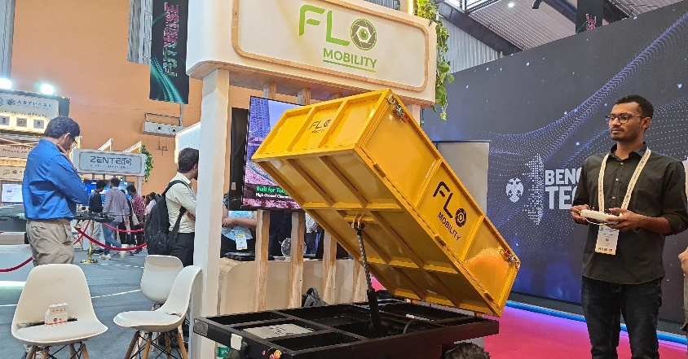
Button
Read Full Article → Bengaluru Start-Up's Made In India Autonomous Wheelbarrow Aims To Transform Construction Workflows

8. Title
Flo Mobility Featured in the India Deeptech Report 2025
Description
Recognized for advancing autonomous robotics and driving innovation in the construction technology sector.
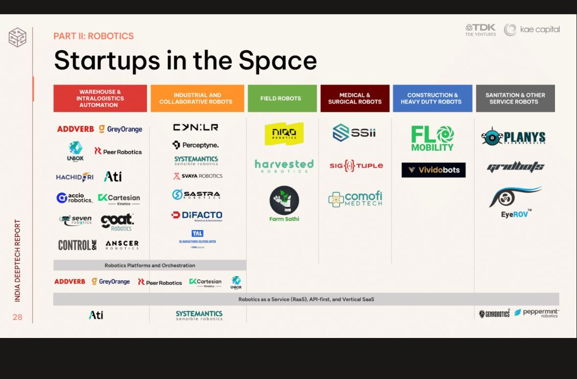
Date
September 2025
9. Title
CNA Singapore Features Flo Mobility in Insight: India and the AI Race
Description
Flo Mobility was featured in CNA's documentary exploring India's AI innovation ecosystem and the startups shaping its future.
Date
2025
Button
Watch Documentary → Insight 2025/2026 - India and the AI Race - CNA

10. Title
Construction World: "We're Building Robots That Flow, Not Just Move"
Description
Founder Manesh Jain shares Flo Mobility's vision for intelligent material movement and the future of construction automation.
Date
June 2025

Button
Read Full Article → We’re building robots that flow, not just move

11. Title
Republic TV Features Flo Mobility on Debate with Arnab
Description
Founder & CEO Manesh Jain joined a national debate on deep-tech innovation, startups, and India's role in shaping the future of technology.
Date
April 2025
Button
Watch Episode → https://youtu.be/zIRonRogjVU?si=fBS5ooB02uwUJmeD
12. Title
Flo Mobility Joins CREDAI New India Summit 2025
Description
Engaging with developers, investors, and industry leaders to accelerate the adoption of construction robotics.

Date
May 2025

13. Title
Runtime Features Flo Mobility's Construction Robotics Innovation
Description
An inside look at Flo Mobility's autonomous construction robots and their impact on safety, productivity, and material movement.
Date
June 2026
Button
Watch Video → https://youtu.be/x-i_OhGSJOA?si=z8qeWhYLSk1JmK6z

14. Title
ARTPARK Showcases Flo Mobility at Startup Mahakumbh 2025
Description
Flo Mobility was featured among ARTPARK's leading deep-tech startups, showcasing innovations in construction robotics and smart mobility.
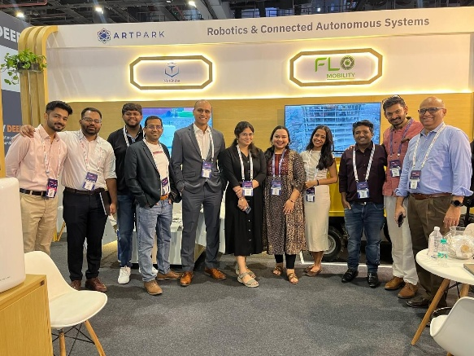
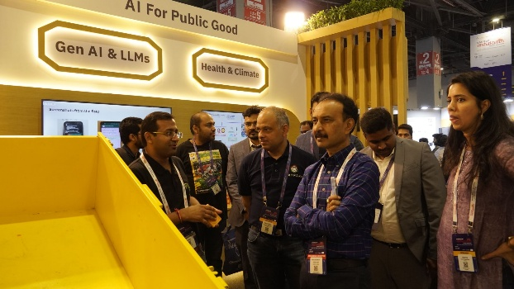
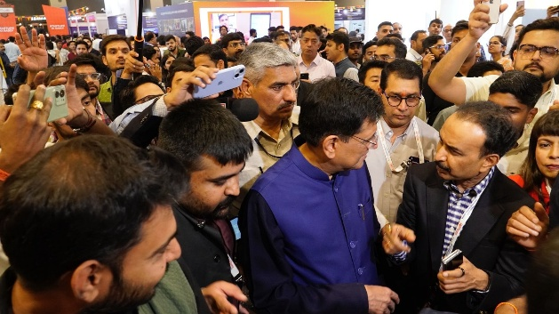
Date
April 2025
15. Title
Flo Mobility Unveils the Hauler at Bengaluru Tech Summit 2024
Description
Flo Mobility officially launched its autonomous Hauler, marking a significant milestone in construction automation and robotics.
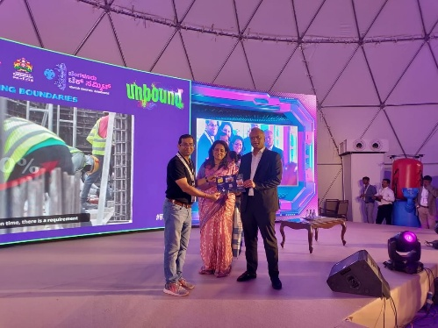
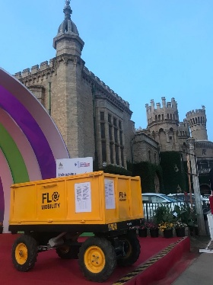
Date
November 2024

16. Title
Flo Mobility's Autonomous Hauler Deployed at Bhogapuram Airport
Description
Flo Mobility's autonomous Hauler was deployed to support material movement at the Bhogapuram Airport infrastructure project.
December 2024
Button
Watch Project → https://youtube.com/shorts/n-svQAaD8gU?feature=share

17. Title
Flo Mobility Launches Operations in Kerala
Description
Flo Mobility officially launched its Kerala operations, inaugurated by Shri P. Rajeev, Hon'ble Minister for Law, Industries & Coir, Government of Kerala, at the Robotics Round Table Conference.
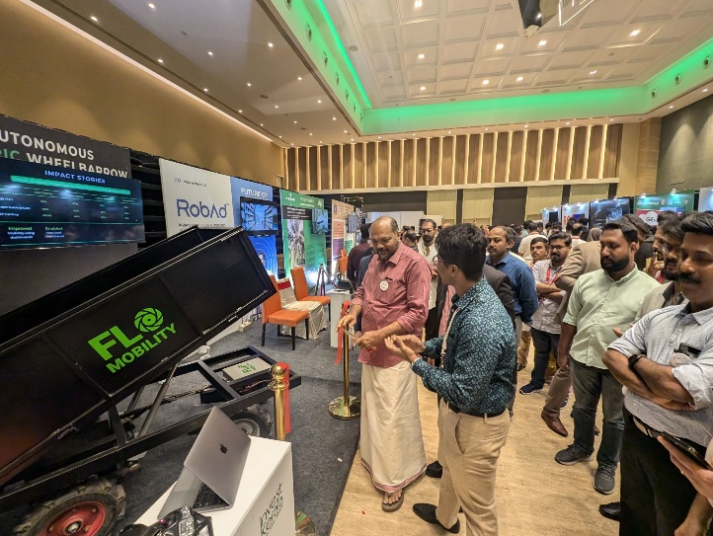
Date
August 2024

ADDITIONS ON MEDIA PAGE
Featured In Logo Strip
Economic Times
YourStory
CNA
Construction World
BuiltWorlds
Republic TV
DD News
ETV Bharat
Runtime
Startupro
Download Press Kit
This is useful for journalists.
Include
- Company Overview
- Logo Pack
- Product Images
- Founder Photos
- Brand Guidelines

Press & Media
Whether you're covering Flo Mobility, requesting an interview, or looking for official brand assets, our team is here to help.
📩 Media Enquiries
media@flomobility.com / email id
Buttons
- Download Press Kit
- Contact Media Team

